Mina, Reign S.

MOBPROG MI182

Wireframe:

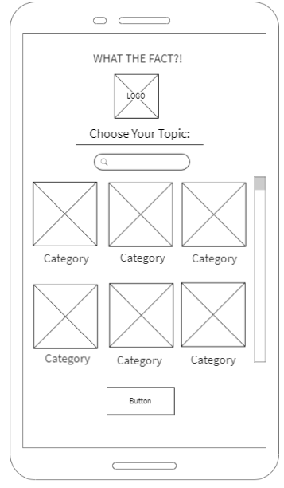

­­­

Mockup: